Soft Computing Class
Semester 2 2023
Assignment 1: Neural Networks
(Worth 20 marks towards your assignment mark)
Due Dates:
Assignment 1 is due (submission on Canvas) on: Sunday 1st October at 11:00pm. You need to get started early.
For this assignment you will do up to 4 tasks using Python and its frameworks (PyTorch or TensorFlow).
A one-paragraph written report/form is required for each task. Grades will be reduced for excessively long written submissions. You will need fill required tables and write one paragraph for each task. Upload codes and report file in zip format at submission portal.
This needs to be done individually. You may discuss what you are doing with others in the class, BUT YOU MUST DO THE WORK YOURSELF.
Tasks 2, 3, and 4 are slightly different for Undergraduate and Postgraduate. Please read information for each task to see the difference.
For data for assignemet1: please download the zip file Data_Assignment1.zip and extract it. For each task there is a folder which you will use data for each task from there.
Task1 – Train a basic MLP
Using the Dermatology dataset train a neural network using the 70-30. Split into test and train. Plot test and training loss function for epoch. Fill the following table and write a paragraph for it.
Filling out the following form is suitable as a one-page submission for this task.

Details of MLP | Hidden Nodes:100  Epochs:200  Hyperparameters: Learning Rate: 0.001, Cross Entropy Loss, Adam Optimizer, Random Seed: 42  Testing Accuracy: 99.074  Training Accuracy: 98.394
Best estimate of test accuracy for a generalised solution. | 98.394%
Paragraph Response:
The learning rate and epochs selected allowed the neural network sufficient time and change in node weights to effectively learn from the data. The resultant accuracy from the neural network, while different for every execution due to data shuffling, the accuracy is not only consistently high, but the difference between train and test accuracy is consistently low, meaning over or under training has not occurred.
The data was relatively clean, though included some dirty data points with unknown ages. The approach with these records was determined from two options:
- Removing the records providing better data overall, but only applicable if the number of records removed would not drastically change the number of records in the data.
- Estimate the age using either another NN or averaging the results.
Due to the lack of dirty records (only 8 from 366) I removed them from the csv file as they did not have a significant effect on the total number of records.
Finally, due to the age attribute the data required scaling via a Standard Scaler.

Task2 – Train a basic CNN and MLP
- Using dataset for prediction of music genre.
- Using diabetes dataset for binary classification.
UG Students: Train a CNN neural network on one dataset (number 1 or number 2) of the data sets provided. (use just one of them). Then train a MLP on the selected dataset which you trained CNN on that and this time train on MLP.
PG Students: Train a CNN neural on all two (number 1 and number 2) of the data sets provided. Train a MLP on the both data sets.
You must determine your best estimate of the accuracy of the resultant classifier for a generalised (i.e. not overtrained or under trained) solution. You should use the 70% train, 30% test data split methodology.
Filling out the following form is suitable as a one-page submission for this task.

Dataset name | Diabetes_binary.csv
Details of CNN | Epochs: 50  Hyperparameters: Kernel Size: 3, 1 Pooling Layer, 1 Batch Norm Layer, 1 Conv Layer (32 Nodes), 0.01 LR  Testing Accuracy: 72%  Training Accuracy:72%
Details on MLP | Epochs: 210  Hidden Nodes: 80  Hyperparameters: LR: 0.001, Random Seed: 42, Adam Optimizer, Cross Entropy Loss  Testing Accuracy: 72.6%  Training Accuracy:72.2%
Best estimate of test accuracy for a generalised solution for CNN. | Approximately 72%
Best estimate of test accuracy for a generalised solution for MLP. | Approximately 72%
Paragraph Response:
Firstly, hyperparameter adjustment caused mostly consistent results. My decision of the final hyperparameters was in an attempt to find a stable point in the loss graphs for each NN.

You can see below that the loss values for each Neural Network resulted in similar value.

The MLP Classifier Neural Network Loss vs Epoch Graph:

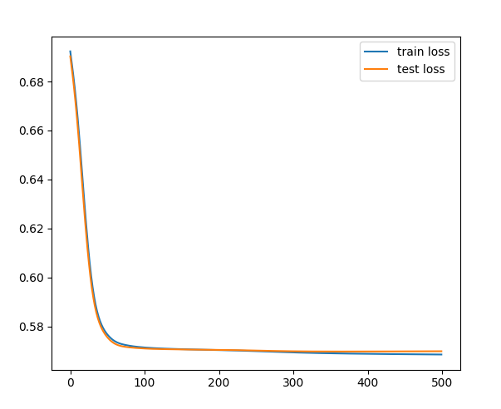

Convolutional Neural Network Accuracy vs Epoch Graph:
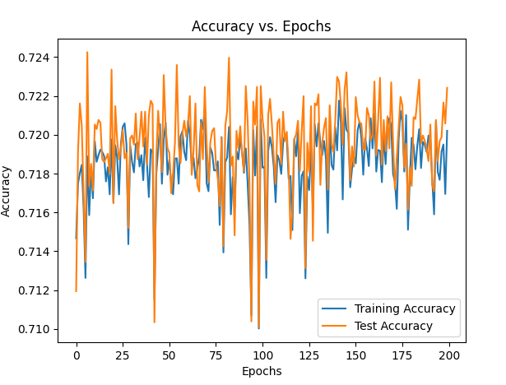

Convolutional Neural Network Loss vs Epoch Graph:

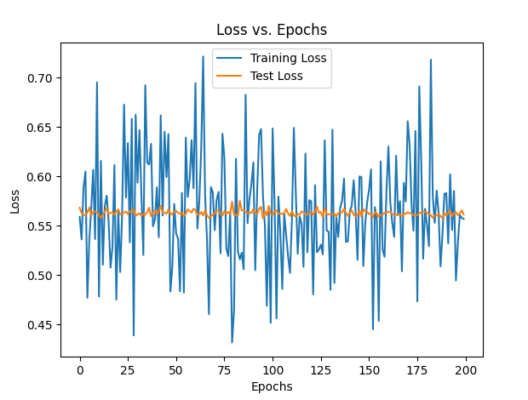

These graphs demonstrate over a reasonable amount of iterations with a reasonable selection of hyperparameters that a CNN and an MLP can reach consistently similar accuracy values for this dataset.

However, the CNN takes significantly longer to train and therefore is too inefficient to warrant using on a dataset like this. The CNN has taken upwards of 3 minutes to train while the MLP takes close to 10-15 seconds. It is much more efficient and should be used for this dataset.

The dataset itself was clean and required StandardScaler processing for the Neural Networks.

Task3 – Build a pretrained model for Chest-Xray dataset
For UG students: use one pretrained model to train and validate the model by using ChestXray image data set. Use train set for training and val set for validation.
For PG students: use two pretrained model to train and validate the model by using ChestXray image data set. Use train set for training and val set for validation. Compare the results of the both pretrained models.
Filling out the following form is suitable as a one-page submission for this task.

Pretained name | AlexNet
Details of model | Epochs:11  Hyperparameters: 0.001 LR, Adam optimizer, Cross Entropy Loss.  Testing Accuracy: 88.62%  Training Accuracy: 91.26%
Best estimate of test accuracy for a generalised solution for pretrained model. | 88.62%
Paragraph Response:

From the testing results, AlexNet seemed to provide the best option for using a pretrained model to provide a prediction output on Chest Xray images. This is due to two reasons:
- Firstly, AlexNet proved to be more efficient while training. It was faster to download and trained much faster than the other models tested/
- Other models seemed to overtrain to a greater degree than AlexNet. You can see in the comparison between graphs that AlexNet’s training and test accuracy are much closer together, meaning the AlexNet model allowed the Neural Network to be trained where the test data received an accuracy closer to that of the training set.

AlexNet =>
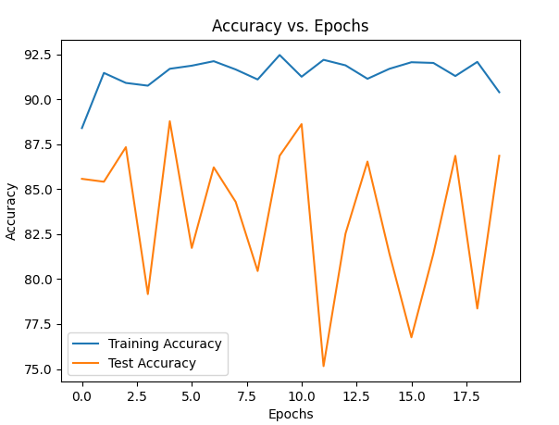
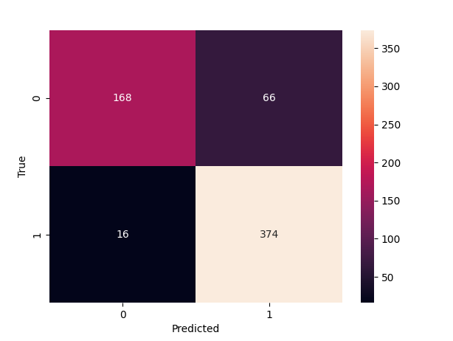

VGG16_BN =>
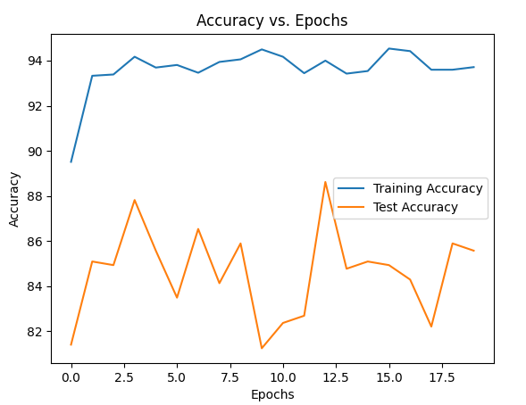
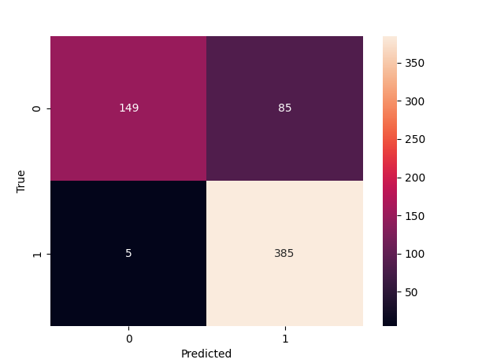

VGG16 =>
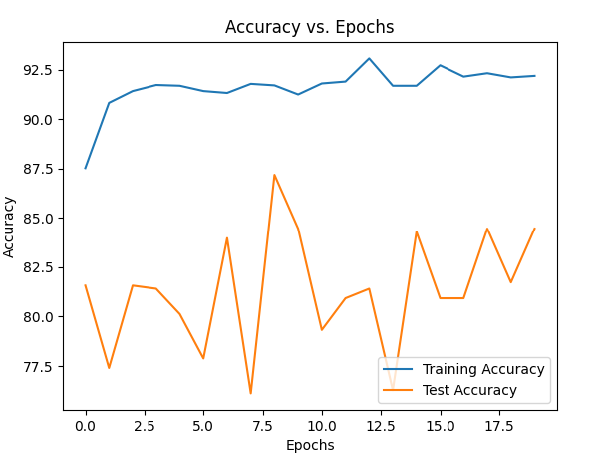
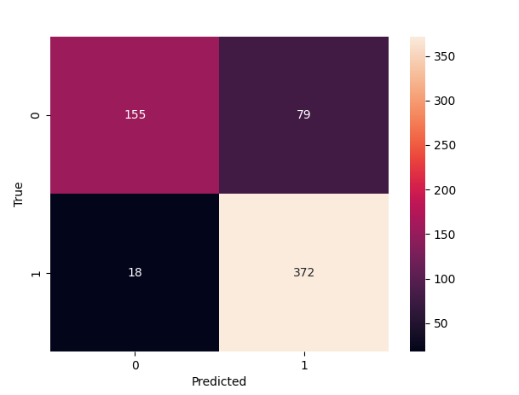

AlexNet’s fewer parameters and less layers seems to make it much more computationally demanding compared to the other models tried. It is simpler, and as such is less demanding of fine-tuning parameters to see better results.

Task4 – Build a LSTM to time series analysis.
Dataset number 1. Miles_Traveled.csv
Dataset number 2: Alcohol_Sales.csv
For UG students: use one dataset (number 1 or number 2) to train and validate (70 to 30) the LSTM model.
For PG students: use two dataset (number 1 and number 2) to train and validate (70 to 30) the LSTM model.
Filling out the following form is suitable as a one-page submission for this task.

Details of LSTM model | Dataset: Alcohol_Sales.csv  Epochs: 400  Hyperparameters: 0.0001 LR, 20 hidden_size, 10 Lookback  Testing RMSE: 0.1256  Training RMSE: 0.0675
Best estimate of test RMSE for a generalised solution for pretrained model. | 0.1256
Paragraph Response:

Firstly, the dataset is relatively clean. The ‘MinMaxScaler’ method was used to scale the Sales values from the dataset to a similar scale. Following this the data was split 70-30 for train and test respectively.

While training the LSTM Model, a variety of values were tested to determine the most optimal hyperparameters for the dataset. See some of the tests below:

Test 1:
1000 Epochs, 20 Lookback, 0.001 LR:
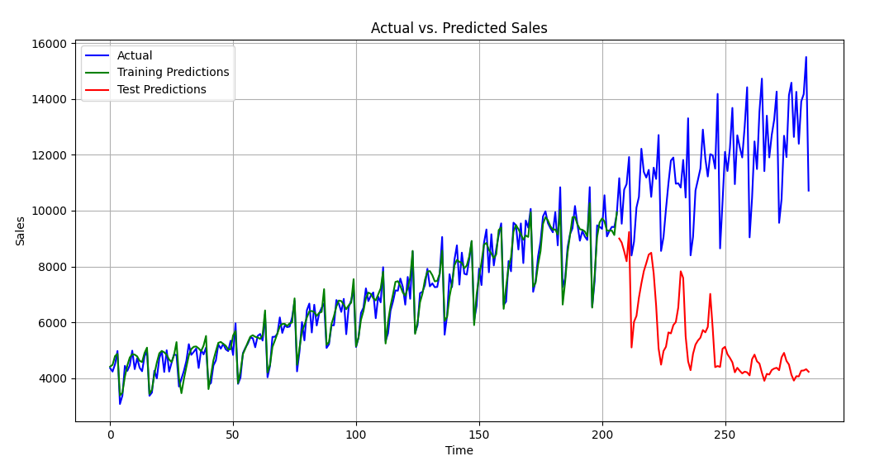
Test Mean Squared Error: 0.3279
Test Root Mean Squared Error: 0.5727

Test 2:
1000 Epochs, 10 Lookback, 0.001 LR:
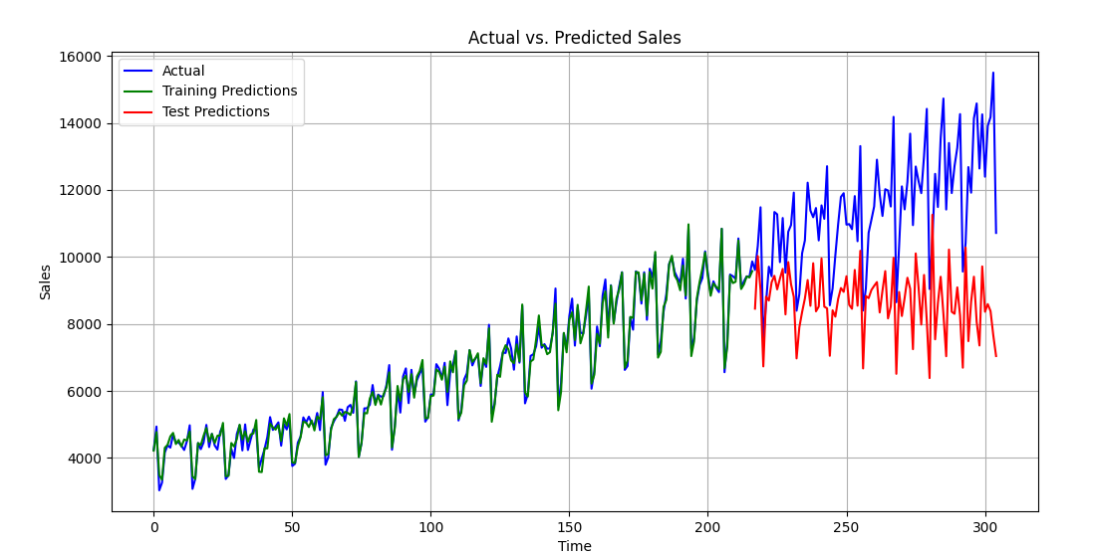
Test Mean Squared Error: 0.0746
Test Root Mean Squared Error: 0.2731

Test 3:
200 Epochs: 10 Lookbacks, 0.001 LR:
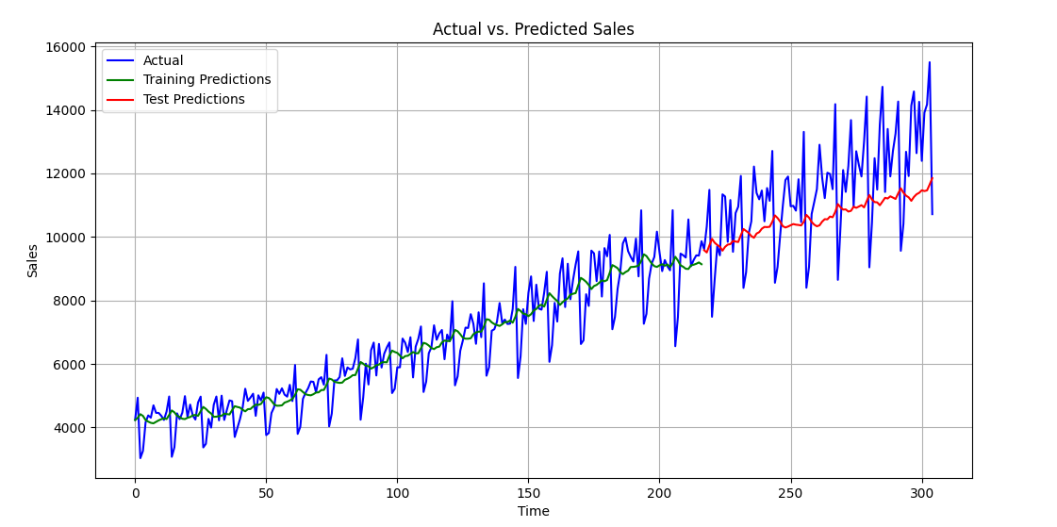
Test Mean Squared Error: 0.0197
Test Root Mean Squared Error: 0.1405

Test 4:
200 Epochs: 10 Lookbacks, 0.01 LR:

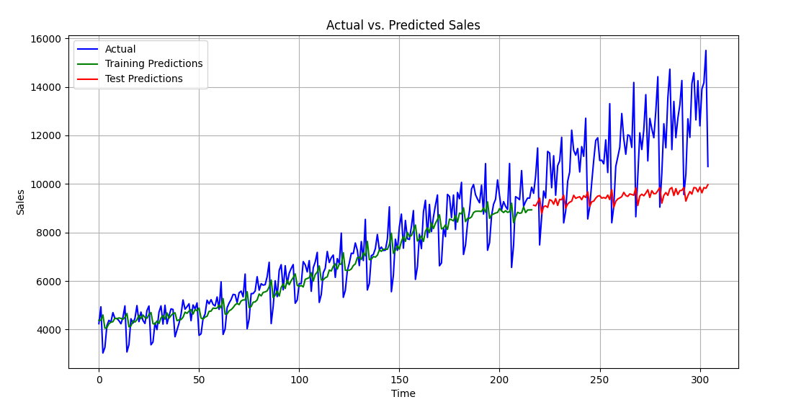
Test Mean Squared Error: 0.0445
Test Root Mean Squared Error: 0.2110

Final Choice:
400 Epoch, 10 Lookbacks, 0.0001 LR:
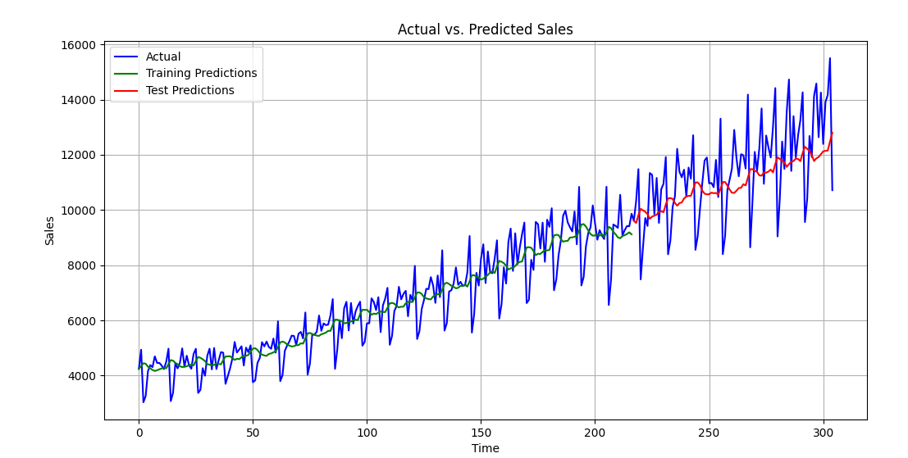
Test MSE: 0.0158, Test RMSE: 0.1256
Train MSE: 0.0046, Train RMSE: 0.0675

Following the testing listed above, the following conclusions can be drawn:
- High epochs resulted in a much lower loss while training but caused a poor performing model while testing due to overfitting. Increasing the lookback with high epochs caused even further overfitting. This can be seen in the first two graphs above.
- Lower epochs result in much higher loss while training but overall performed significantly better with the test data evaluation. An increase in the learning rate caused poor predictions with the test data as seen in tests 3 & 4.
- A mid-range of epochs (400) showed the best middle ground between low loss values while training and high performing test results. The learning rate was decreased, due to the large amount of data and epochs allowing for more precise adjustments to node weights.

